[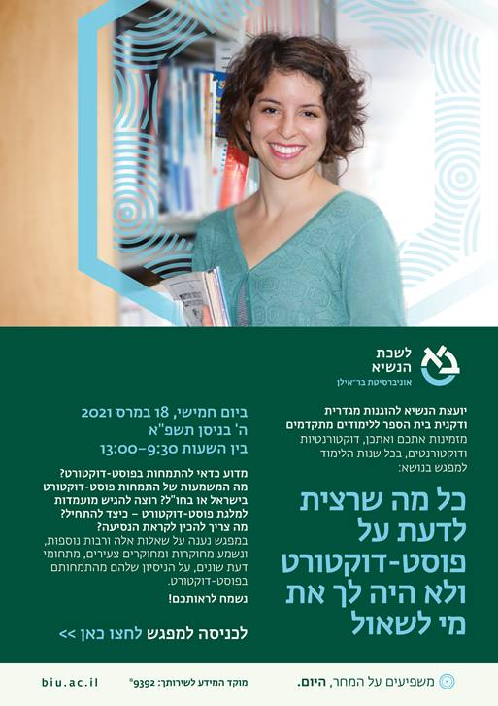](https://eur02.safelinks.protection.outlook.com/?url=https%3A%2F%2Fus02web.zoom.us%2Fj%2F2013629587&data=04%7C01%7CGeog.Dept%40biu.ac.il%7Ccb4eadb12bce4644427a08d8de26136f%7C61234e145b874b67ac198feaa8ba8f12%7C1%7C0%7C637503602425270623%7CUnknown%7CTWFpbGZsb3d8eyJWIjoiMC4wLjAwMDAiLCJQIjoiV2luMzIiLCJBTiI6Ik1haWwiLCJXVCI6Mn0%3D%7C1000&sdata=ALWhs8d7RU9spv2Cmr886AxeWStZRry8iBX2RDanu70%3D&reserved=0)